Copyright for test papers and marking guides remains with *West Australian Test Papers.*

Test papers may only be reproduced within the purchasing school according to the advertised Conditions of Sale.

Test papers should be withdrawn after use and stored securely in the school until Wednesday 10th October 2018.



**MATHEMATICS**

**METHODS**

**UNITS 3 & 4**

**Semester Two**

**2018**

**SOLUTIONS**

***Calculator−free Solutions***

1. (a) 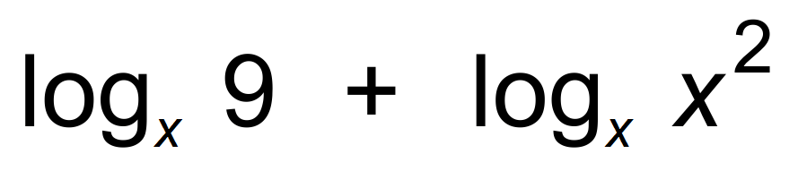 ✓

= 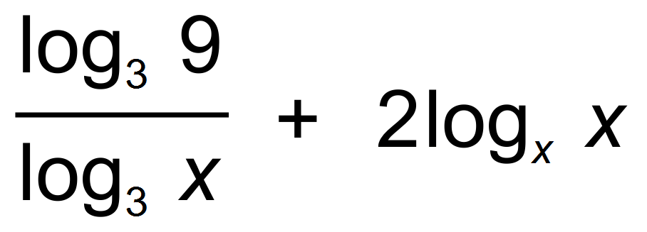 ✓

= 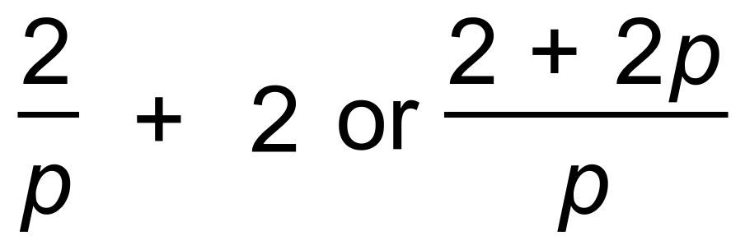 ✓

(b) 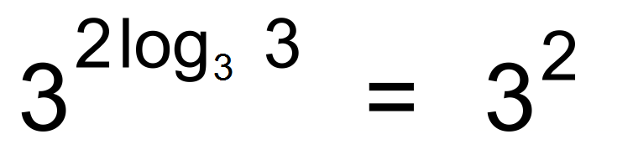 ✓

= 9 ✓

(c) 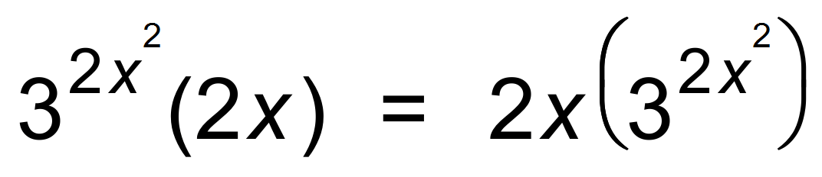 ✓✓ [7]

2. (a) 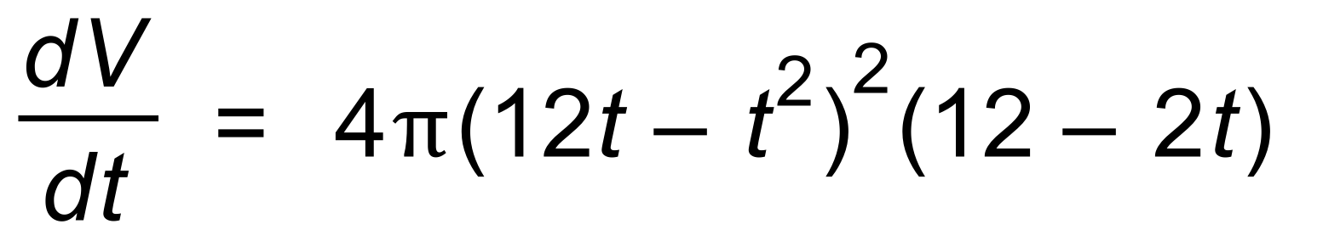 ✓

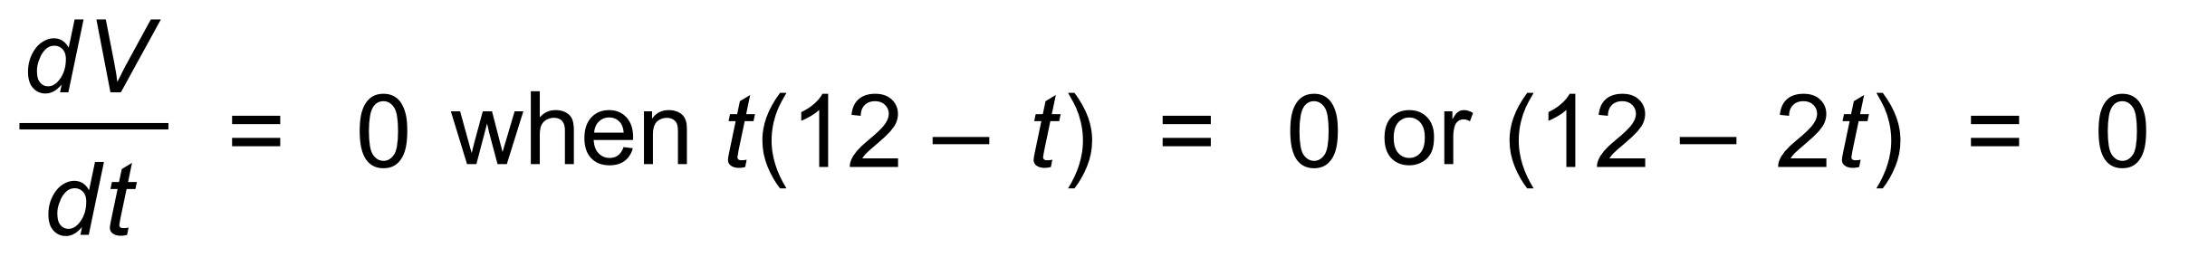 ✓

∴ 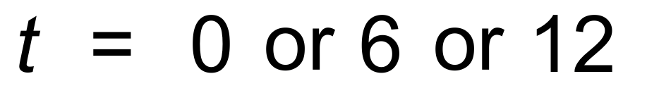 ✓

Using the sign table yields Maximum occurs at t = 6 ✓

(b) (i) 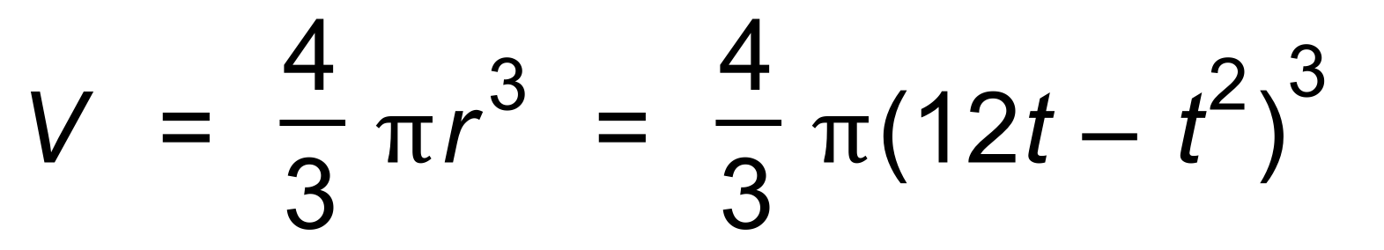 ✓

∴ 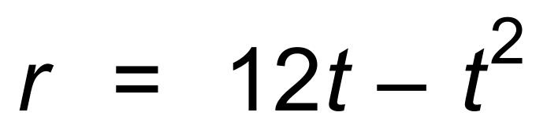 ✓

(ii) When 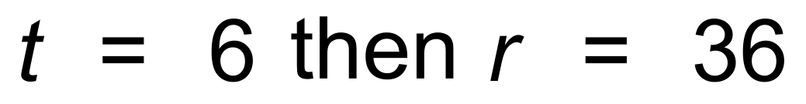 ✓

r =36 is the maximum value of r, so max Volume. ✓ [8]

3. (a)  ✓

= 2.35 ✓

 ✓

= 3.25 ✓

(b) 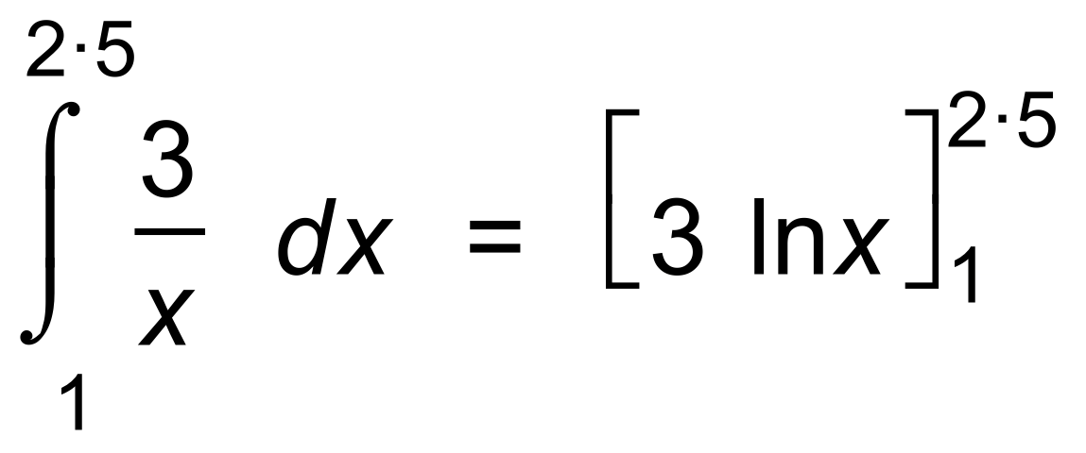 ✓

=  ✓ [6]

4. (a) 0.07 ✓

(b) 0.25 ✓

(c) P(1) = (0.1)2 = 0.01

P(2) = (0.15)2 = 0.0225 ✓

∴ P(1) + P(2) = 0.0325 ✓

(d) Unbiased would be uniform ✓ [5]

5. (a) 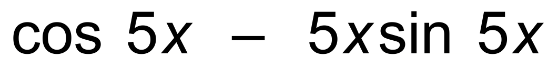 ✓✓

(b) 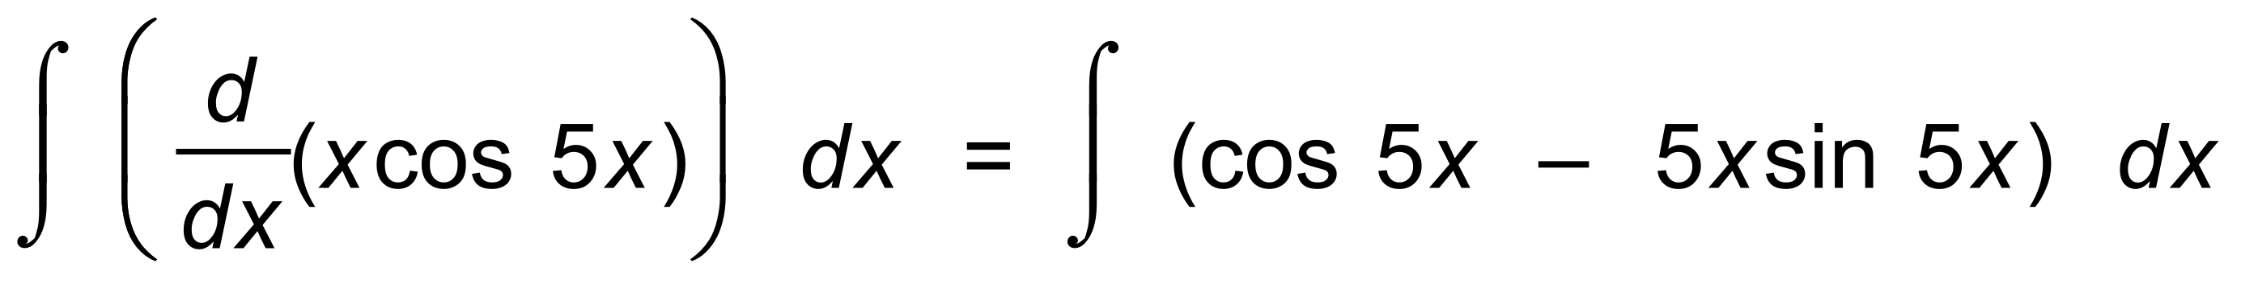 ✓

∴ 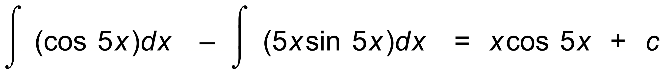 ✓

∴ 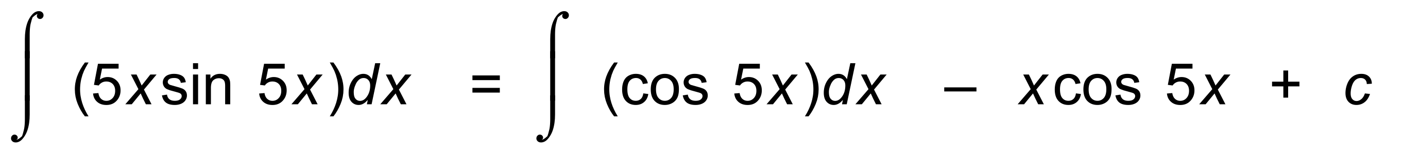 ✓

∴ 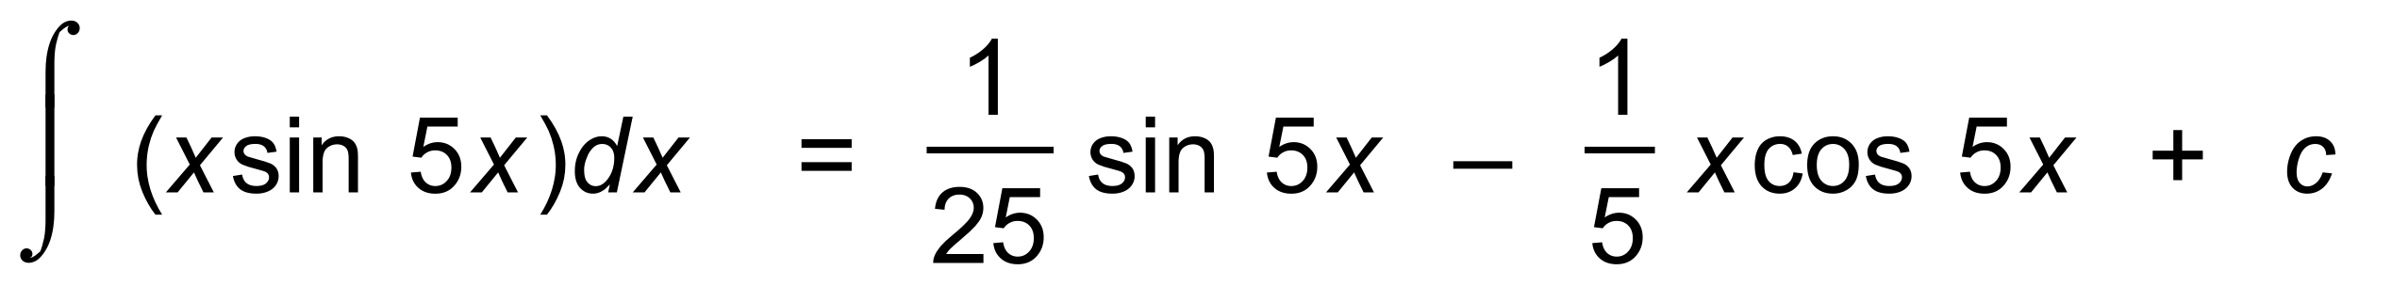 ✓ [6]

6. 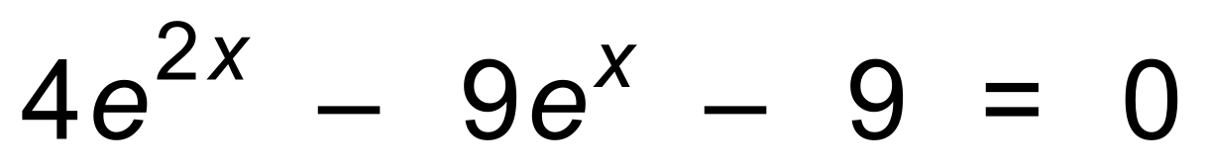

Let 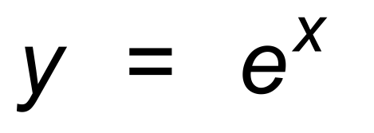

∴ 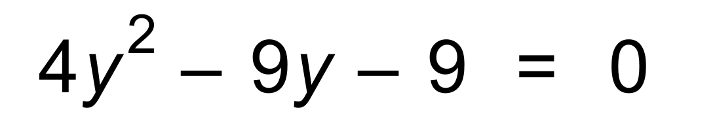 ✓

∴ 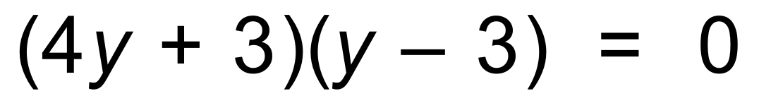 ✓

∴ 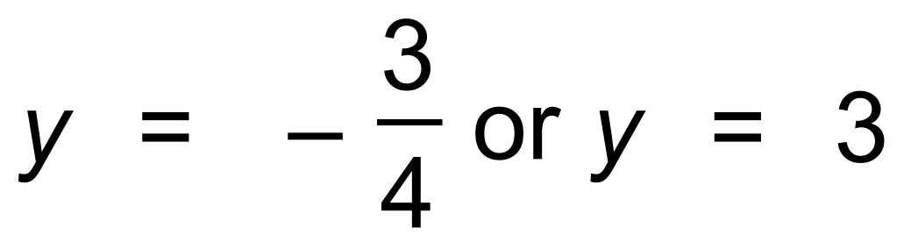 ✓

∴ 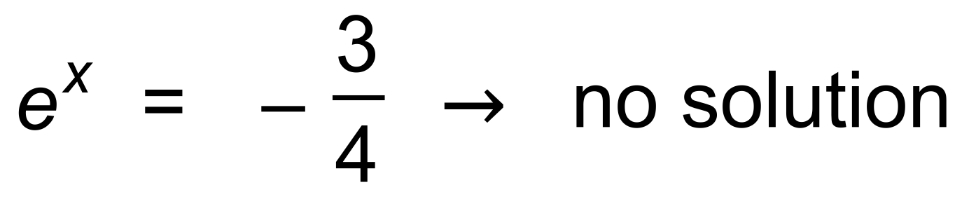 ✓

and 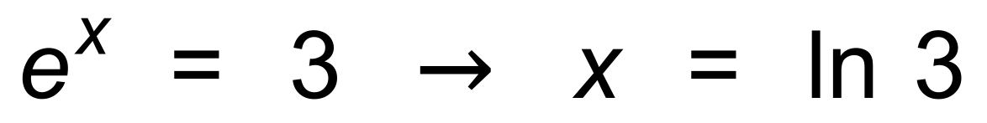 ✓ [5]

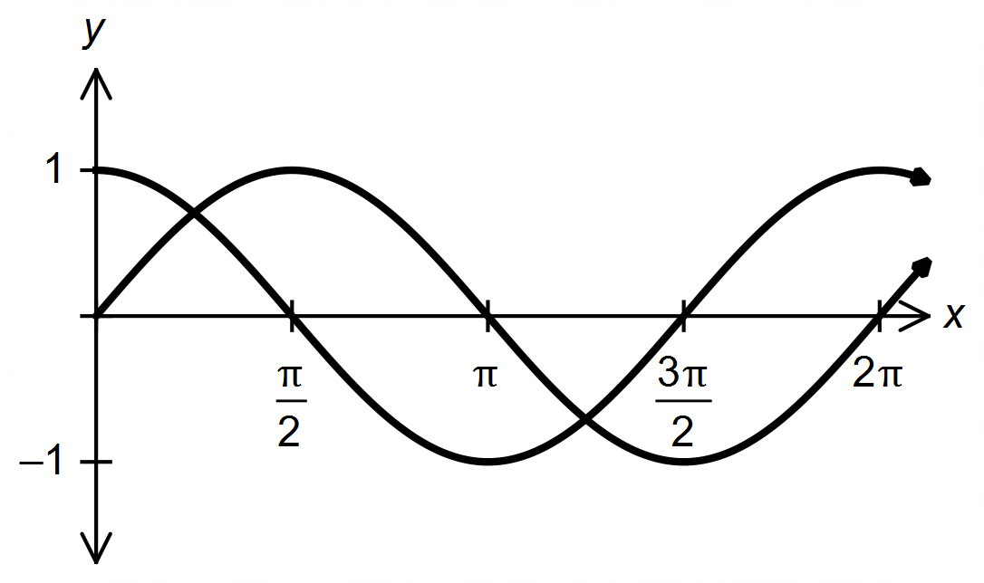7. (a)

✓✓

(b) 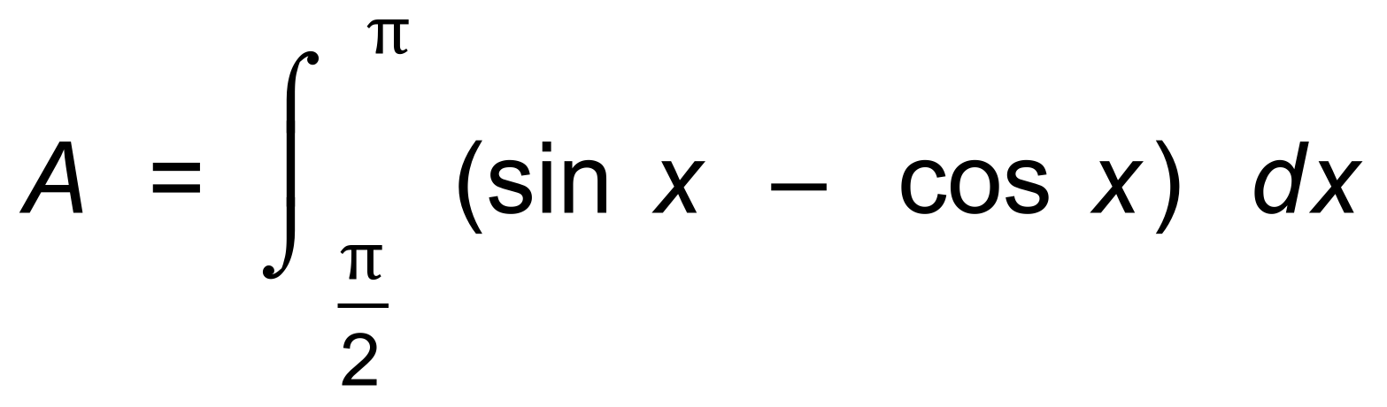 ✓

= 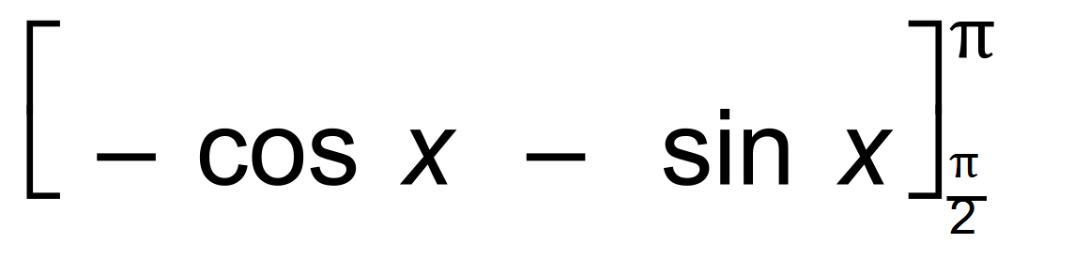 ✓

= (0 + 1) −(−1 − 0) = 2 ✓ [5]

8. 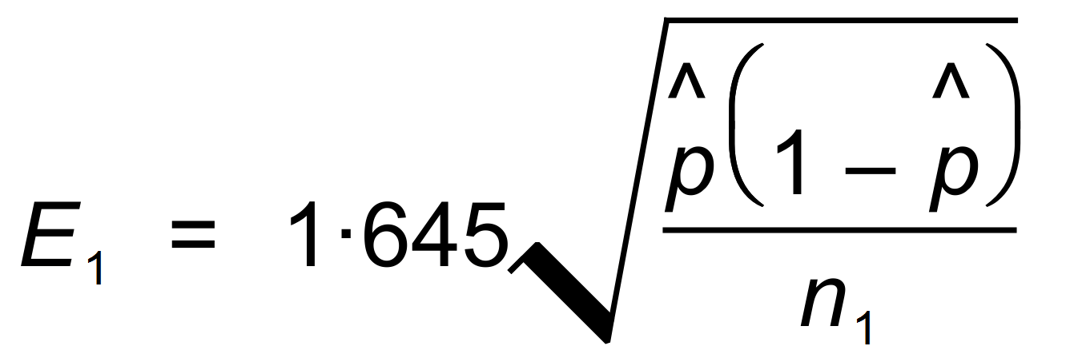

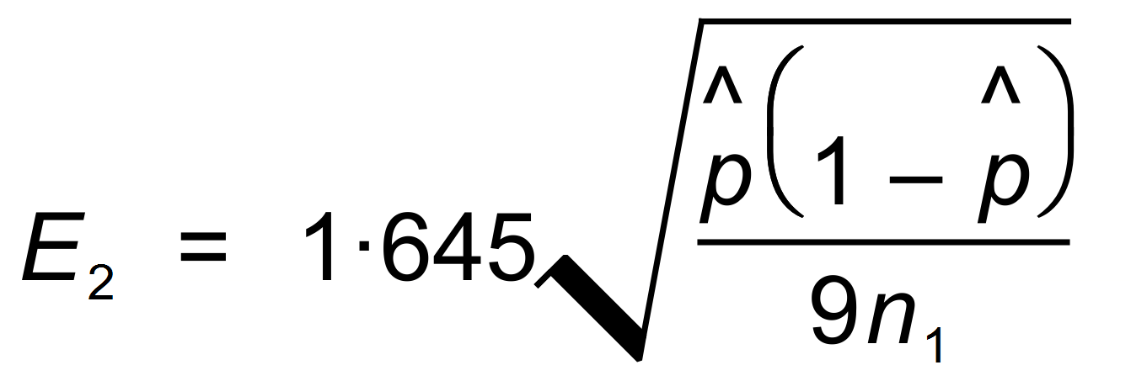 ✓

∴ 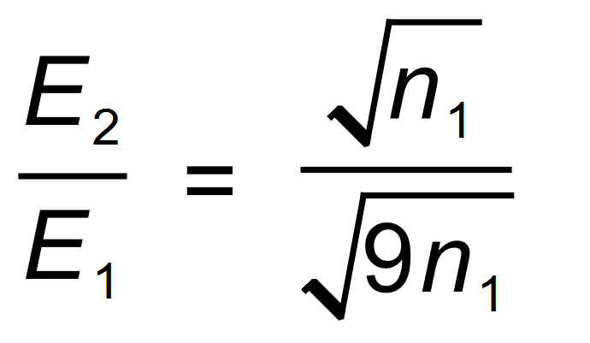 ✓

= 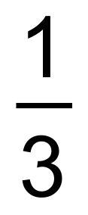 ✓ [3]

9. (a) ln |sin x| + c ✓✓

(b) 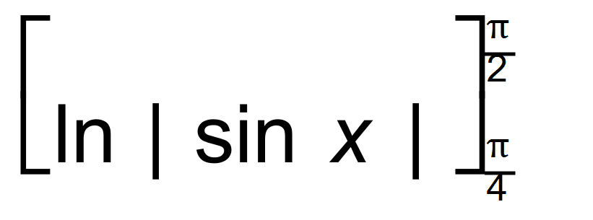 ✓

= 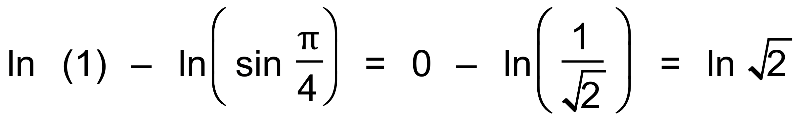 ✓

= 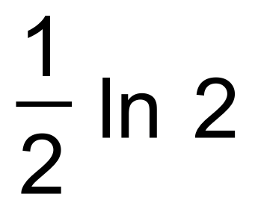 ✓ [5]

***Calculator−assumed Solutions***

10. (a) 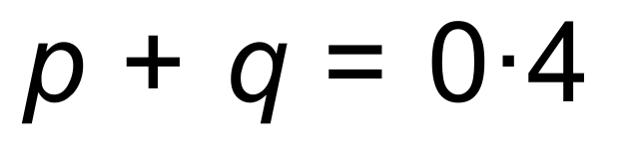 ✓

 ✓

∴ From CAS p = 0.3 and q = 0.1 ✓

(b) E(X) = 0.2 + 0.6 + 0.9 + 0.4 + 0.5 = 2.6 ✓

(c) E(Y) = 1 − 5.2 = −4.2 ✓ [5]

11. (a) 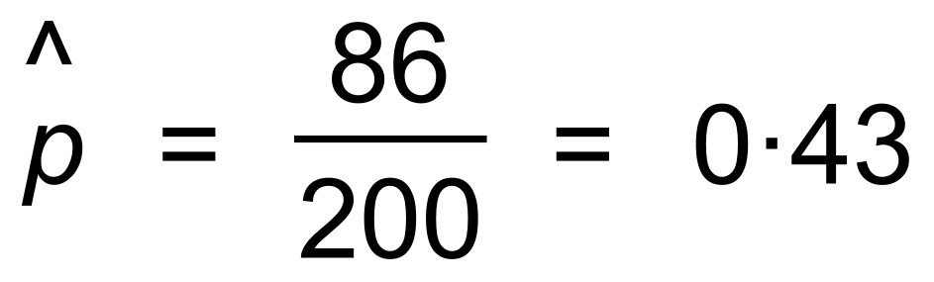 ✓

(b) 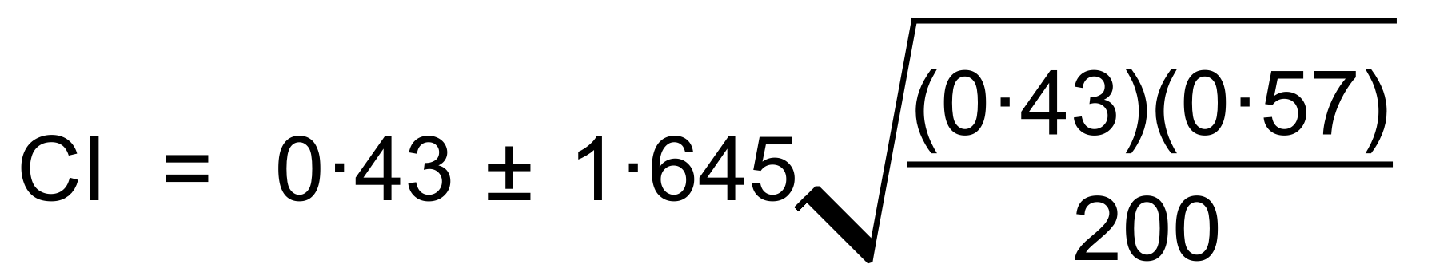 ✓✓

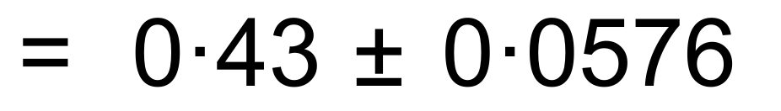 ✓

∴ 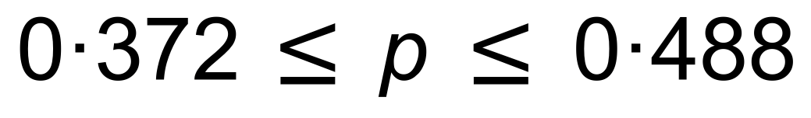 ✓

(c) The mean suggested by the CI is 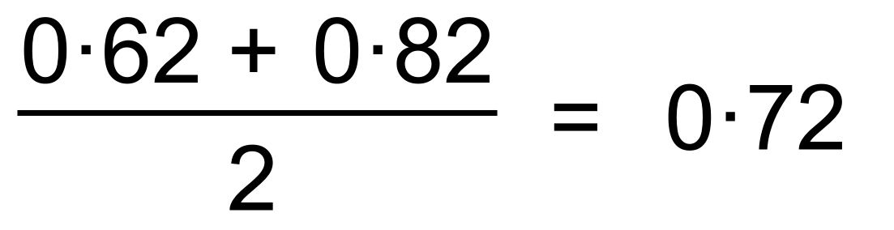 ✓

This does not lie within the 90% CI as calculated in (b) ✓

∴ Evidence doesn’t support the claim. ✓

(d) (i) Binomial requires independent events and a constant

probability of success. Neither criteria apply here. ✓

(ii) 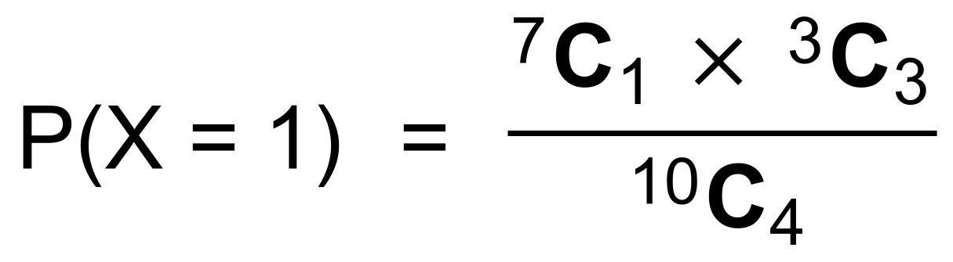 ✓✓

= 0.1 ✓ [12]

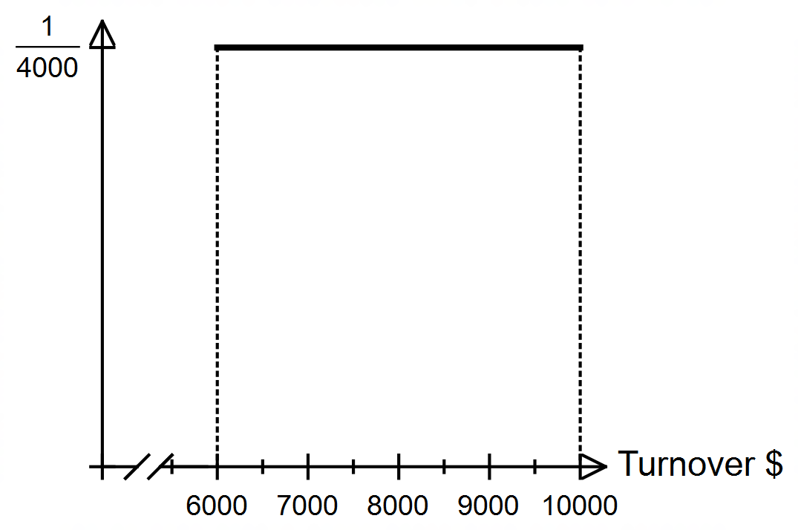12. (a)

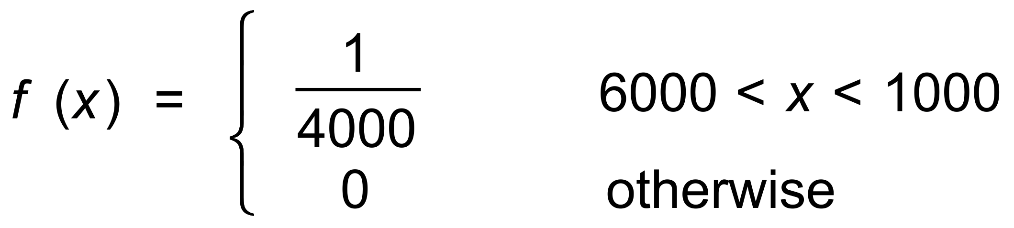

✓✓

(b) (i)  ✓

(ii) 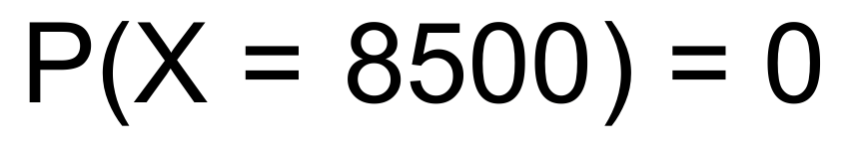 ✓

(c) 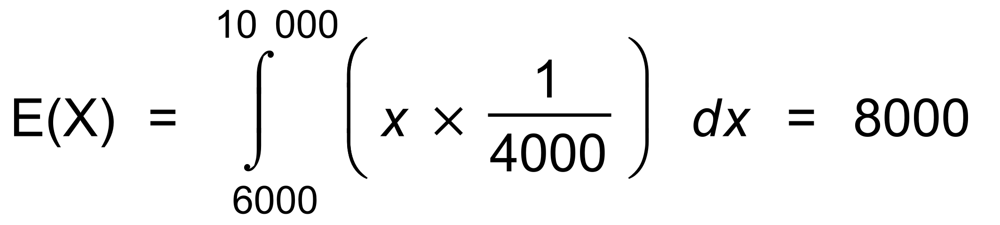 ✓✓

(d) (i) 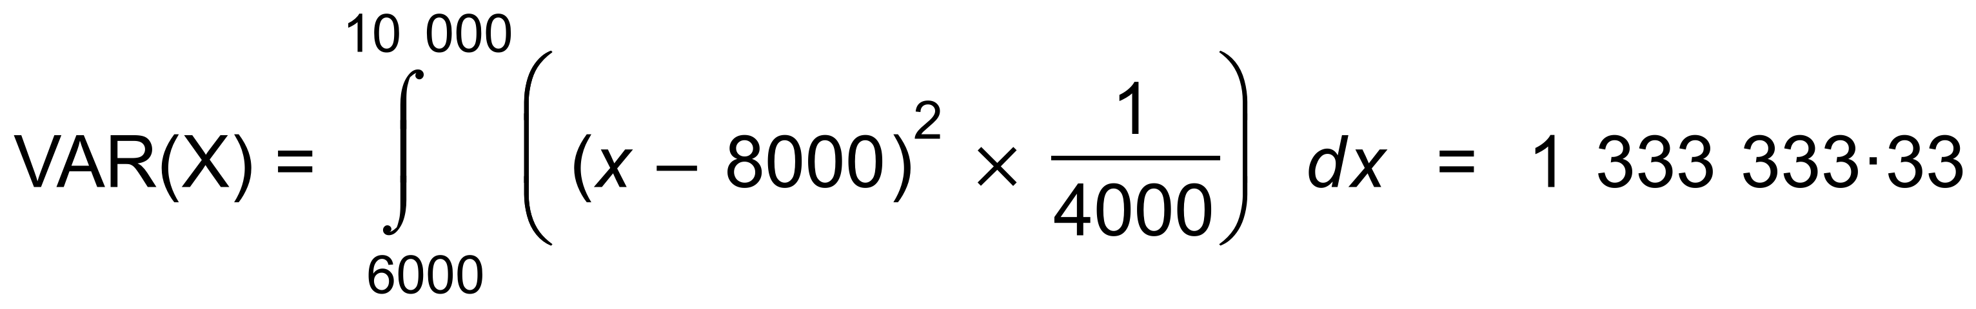 ✓✓

∴ 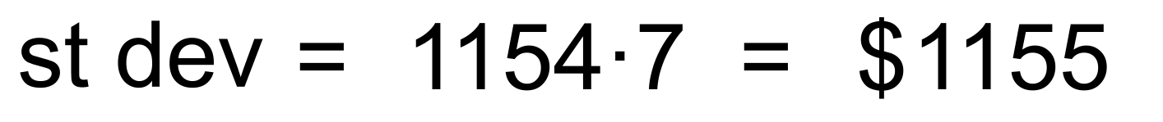 ✓

(ii) Standard deviation = $1155

Not affected by change of origin ✓ [10]

13. (a) (i) 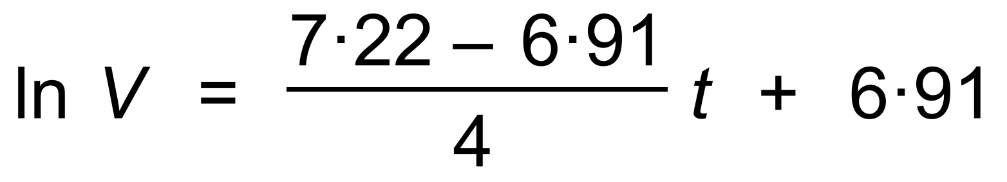 ✓

∴ 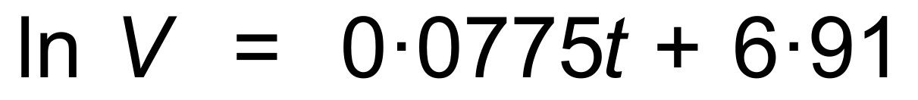 ✓

(ii) 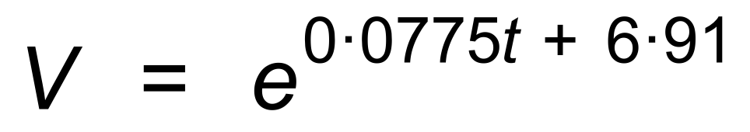 ✓

∴ 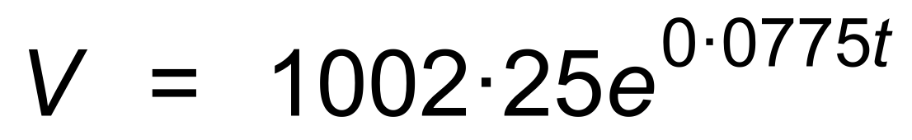 ✓

(b) 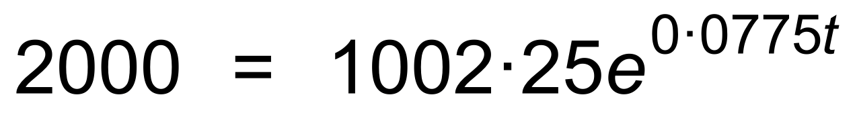 ✓

∴ 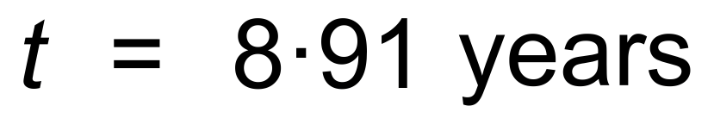 ✓

(c) 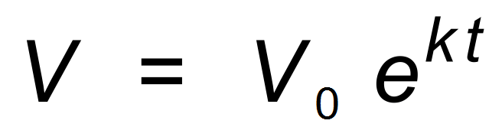

∴ 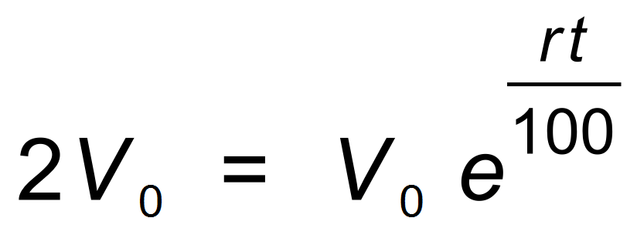

∴ 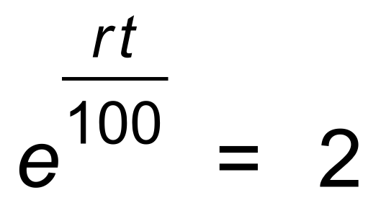 ✓

∴ 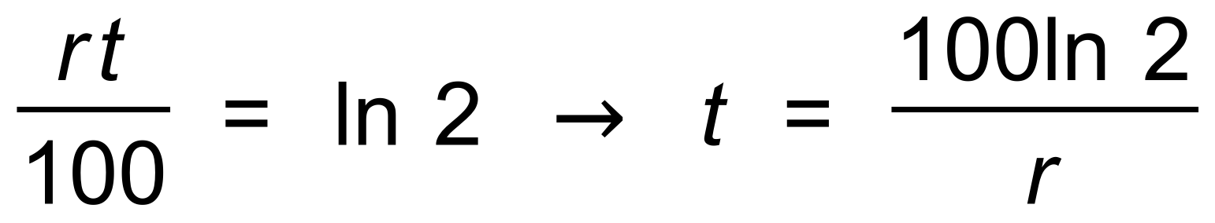 ✓

∴ 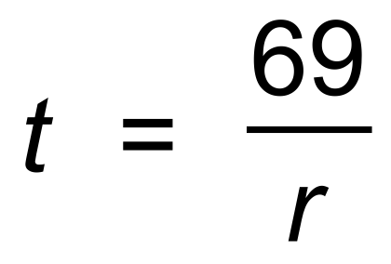 ✓ [9]

14. (a) 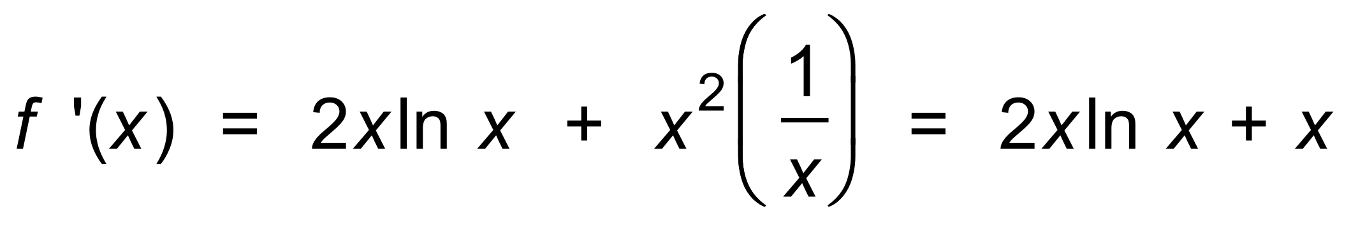 ✓

∴ 

∴ 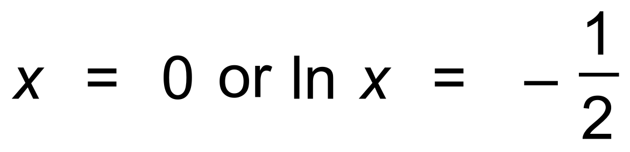 ✓

ie 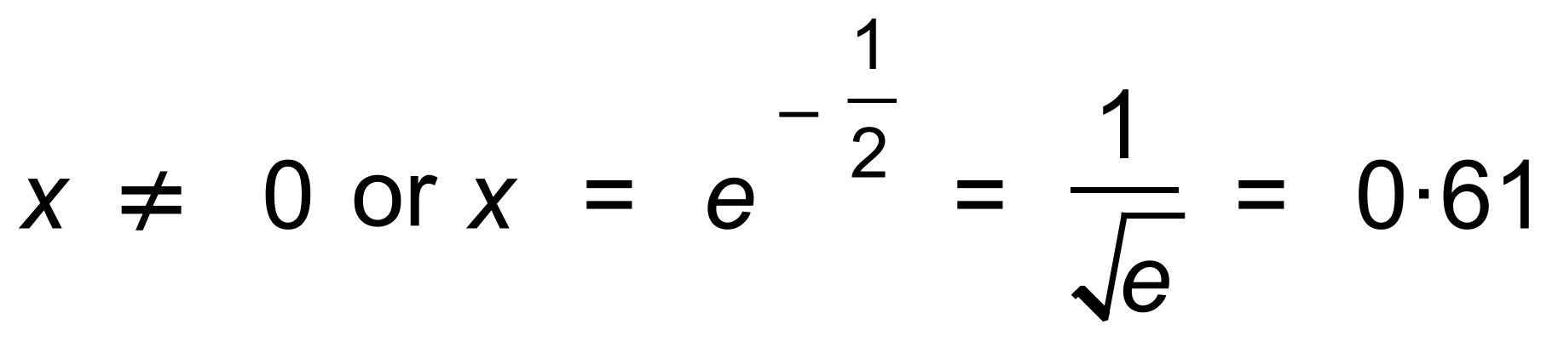 ✓

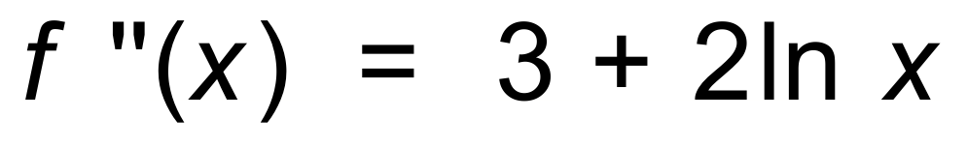 ✓

∴  ✓

(b) 

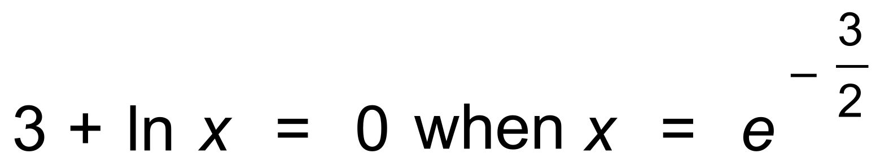 ✓

∴ Oblique POI at 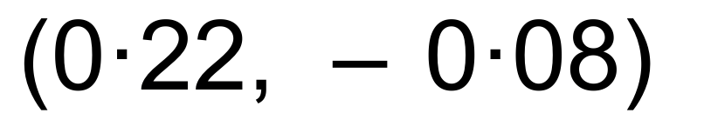 ✓✓

(c)

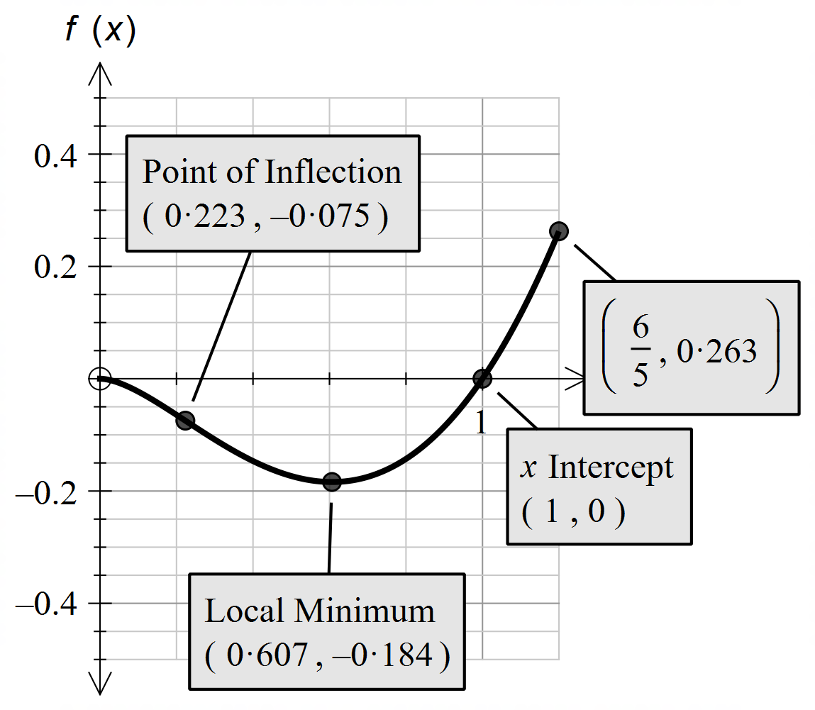

✓✓✓✓ [12]

15. (a) (i) 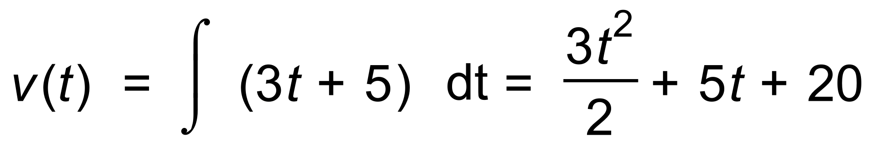 ✓✓

∴ 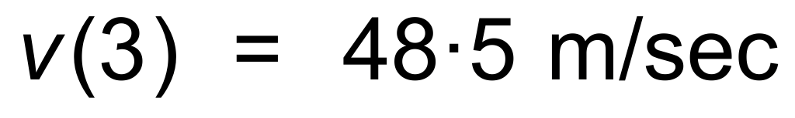 ✓

(ii) 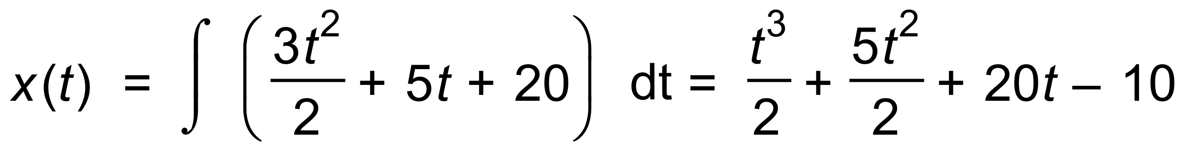 ✓✓

∴ 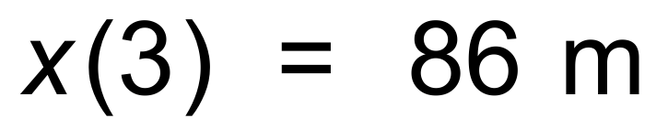 ✓

(b) 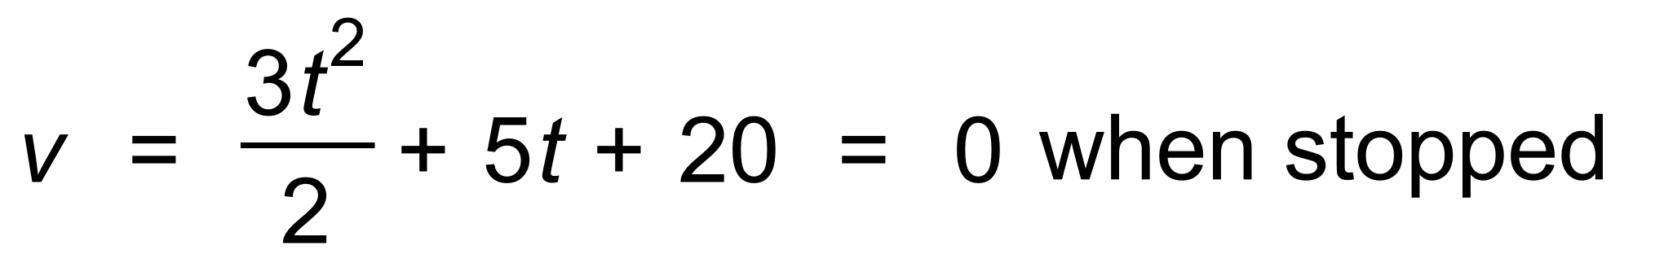 ✓

However 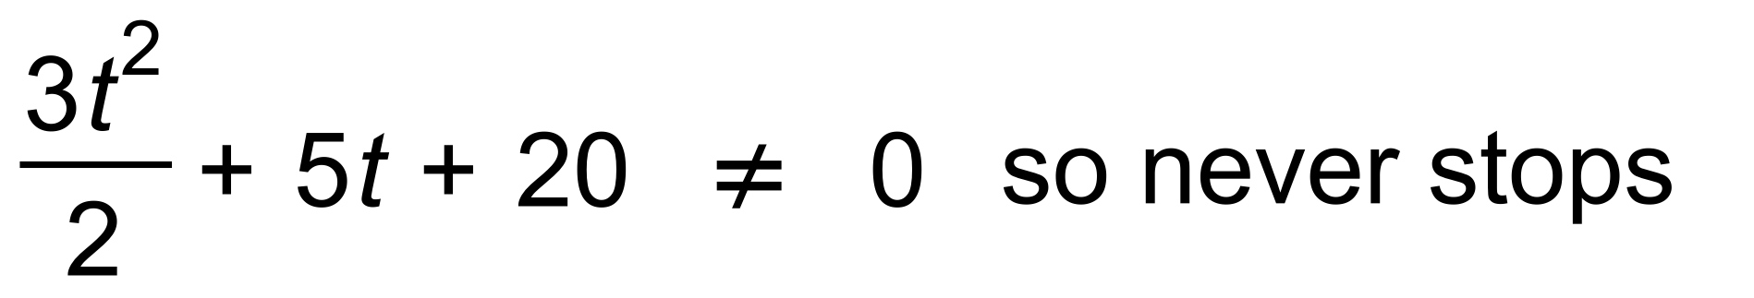 ✓

(c) Distance travelled = 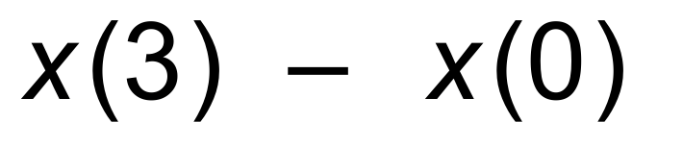 ✓

∴ 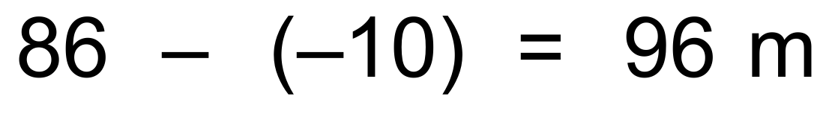 ✓ [10]

16. 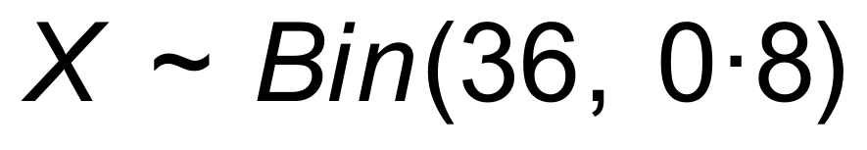

(a) 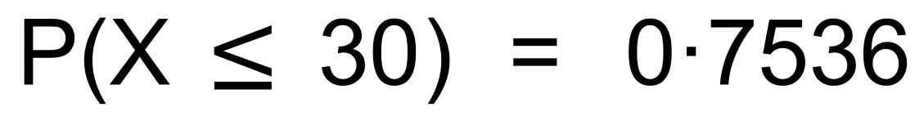 ✓✓

(b) (i) 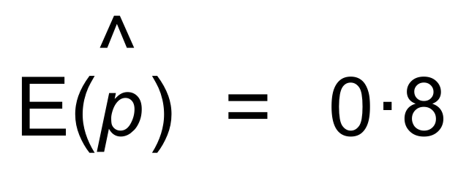 ✓

(ii) 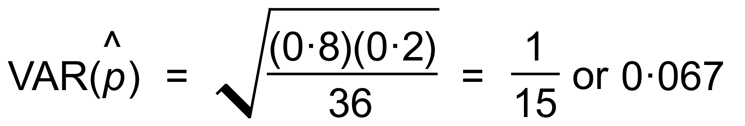 ✓✓

(c) (0.9)10 = 0.349 ✓✓ [7]

17. (a) Take proportions as follows:

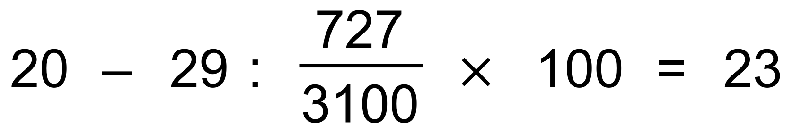

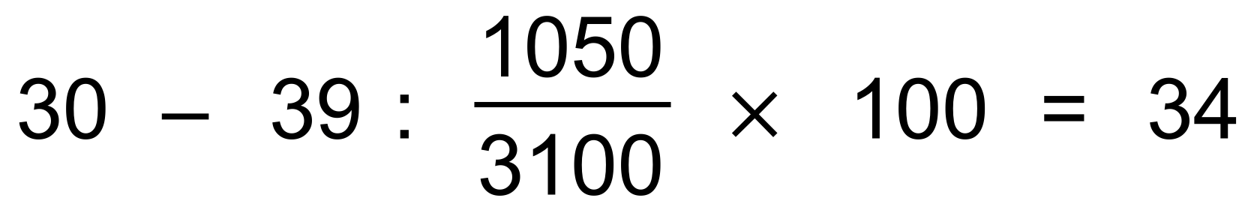 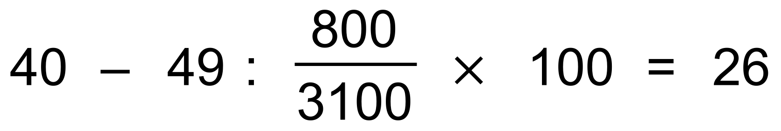 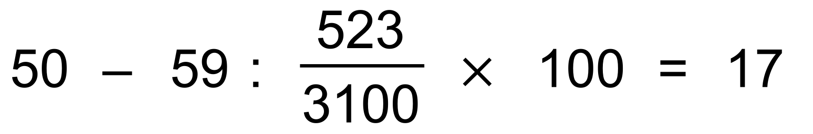 ✓✓✓

(b) (i) Normal distribution ✓

(ii) 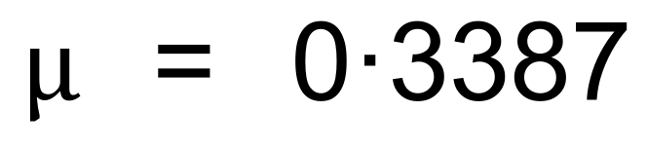 ✓

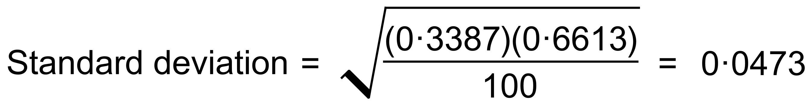 ✓

(c) 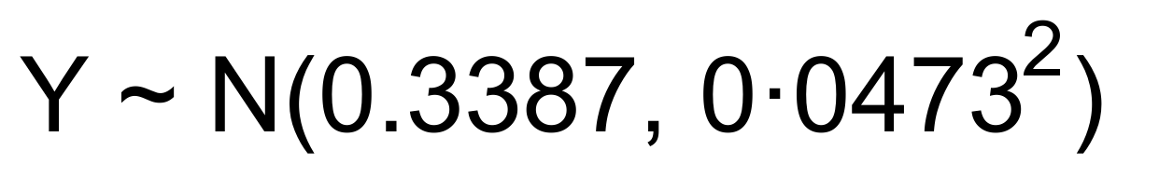 ✓

∴  ✓✓ [9]

18. (a) 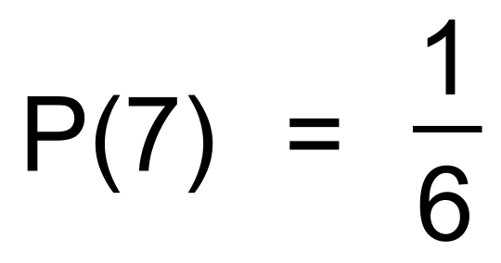 ✓

(b) 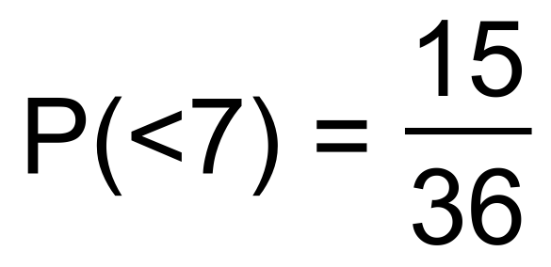 ✓

(c) 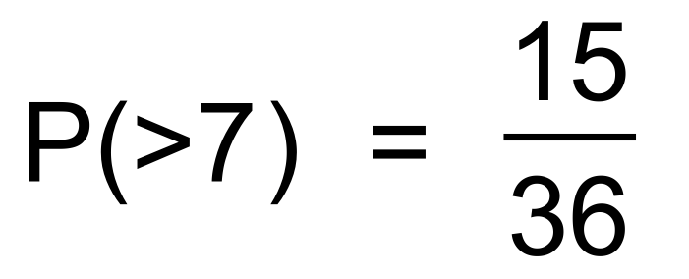 ✓

(d) $12 ✓

(e)

|  |  |  |  |
| --- | --- | --- | --- |
| Game | 7s | Unders | Overs |
| P(X) |  |  |  |
| Return | 20 | 1 | 1 |

∴ E(X) = 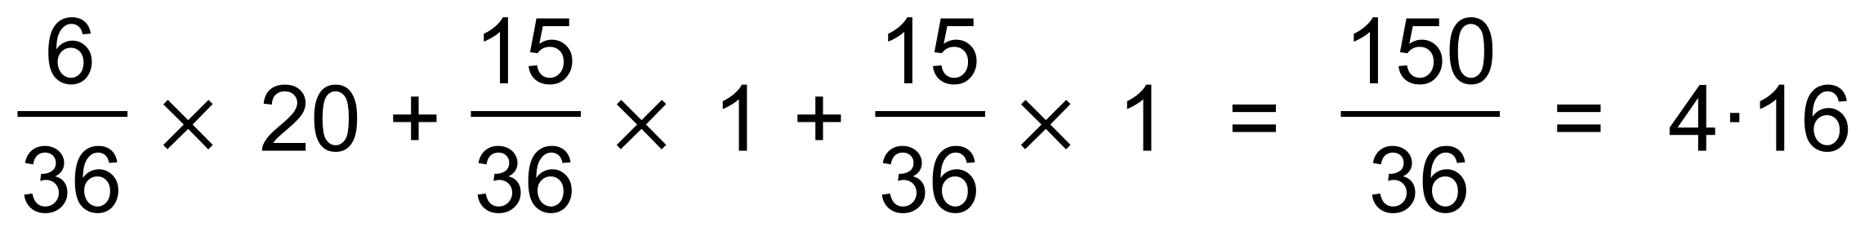 ✓✓

∴ Club makes $5 − $4.16 = 84 cents per roll ✓ [7]

19. (a) 

= 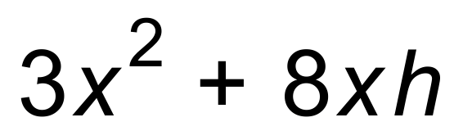 ✓

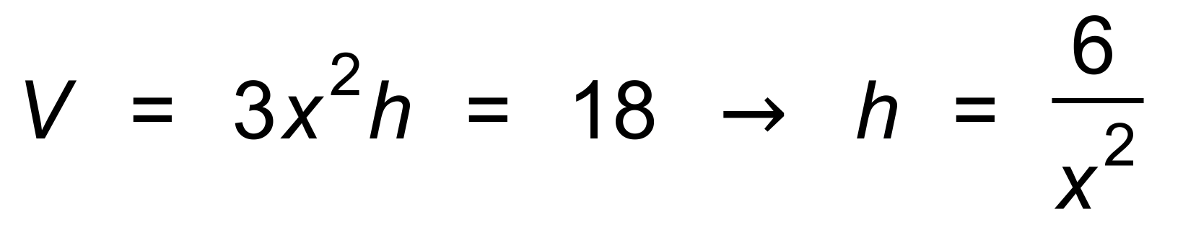 ✓

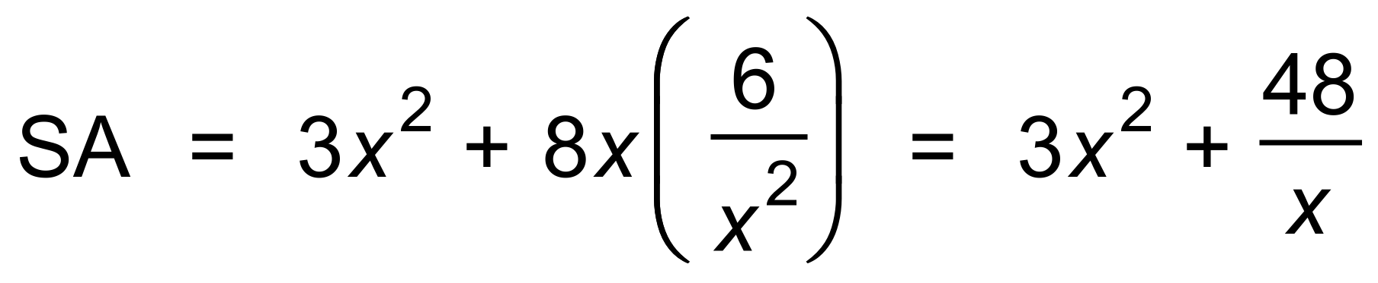 ✓

(b) 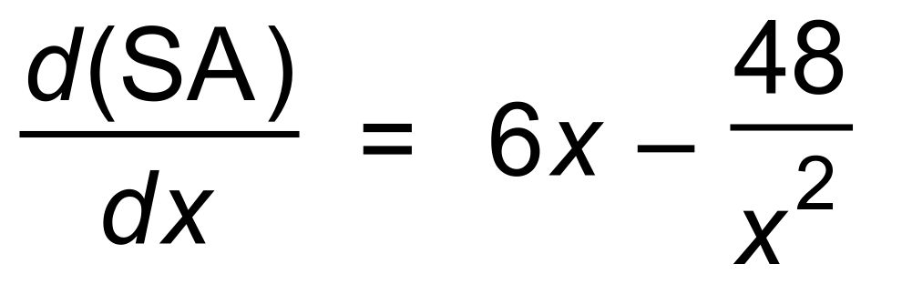 ✓

∴ Max occurs when 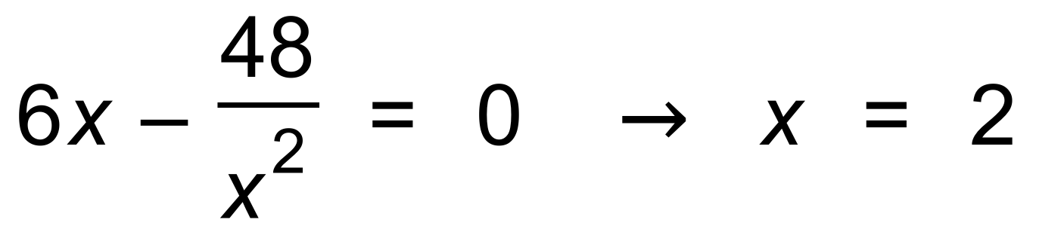 ✓

∴ *h* = 1.5 and SA = 36 m2 ✓

(c) 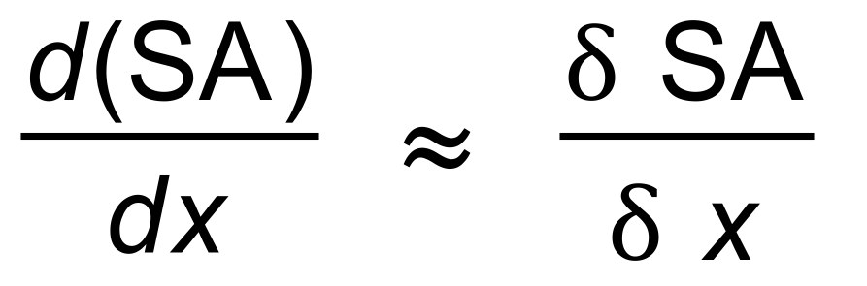

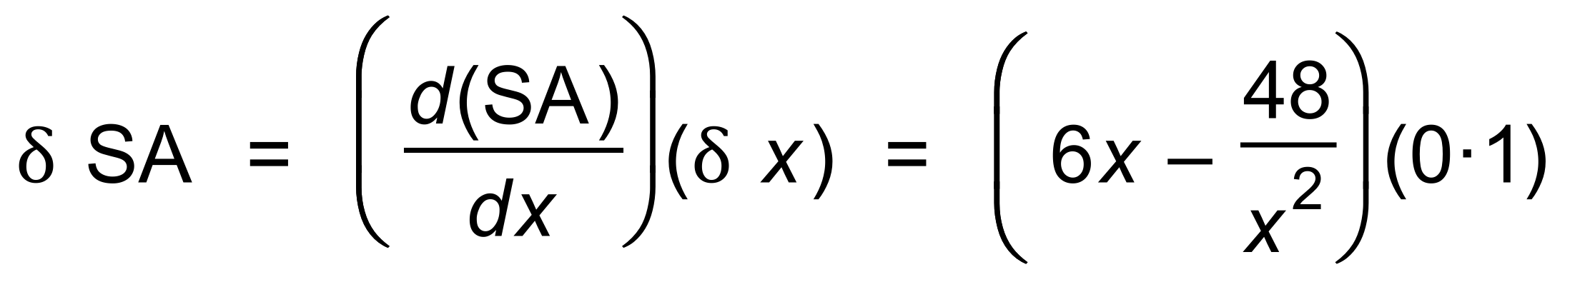 ✓

 ✓

(d) 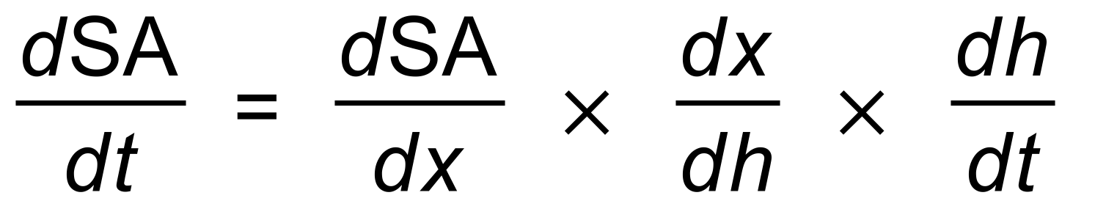

= 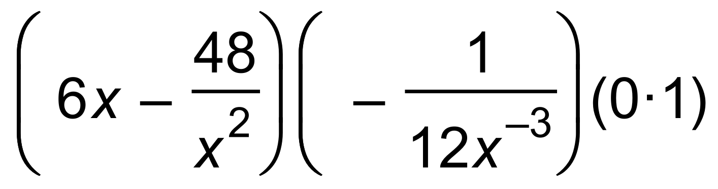 ✓✓

When *x* = 1, 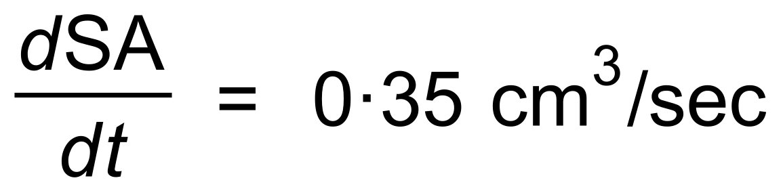 ✓ [11]

20. (a) 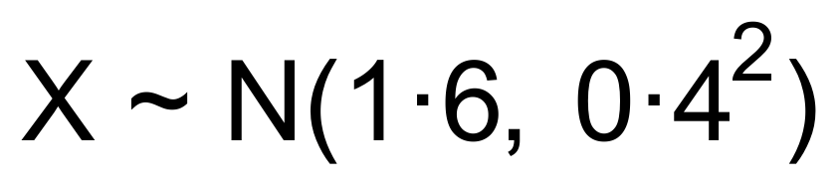

P(X > 2) = 0.1587 ✓✓

(b)  ✓✓

(c) (i) X ~ Bin(4, 0.1587) ✓

∴ P(X = 1) = 0.378 ✓

(ii) 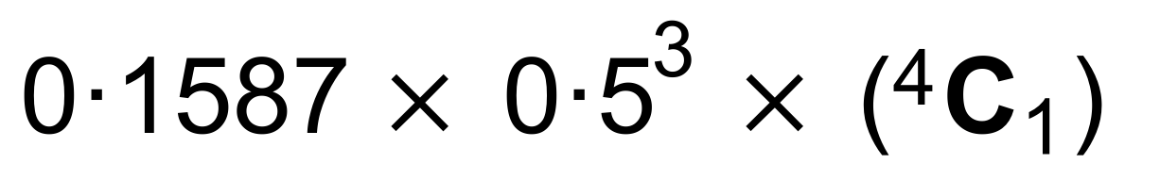 ✓

= 0.0794 ✓ [8]